**QNO:2**

**package** CA1;

**import** java.util.List;

**import** org.openqa.selenium.By;

**import** org.openqa.selenium.JavascriptExecutor;

**import** org.openqa.selenium.Keys;

**import** org.openqa.selenium.WebDriver;

**import** org.openqa.selenium.WebElement;

**import** org.openqa.selenium.chrome.ChromeDriver;

**import** org.openqa.selenium.chrome.ChromeOptions;

**import** org.testng.annotations.Test;

**import** io.github.bonigarcia.wdm.WebDriverManager;

**public** **class** ca1_2 {

@Test

**public** **void** f() **throws** InterruptedException {

WebDriverManager.*chromedriver*().setup();

ChromeOptions co=**new** ChromeOptions();

co.addArguments("--remote-allow-origins=*");

WebDriver driver=**new** ChromeDriver();

driver.get("https://www.amazon.in");

driver.manage().window().maximize();

Thread.*sleep*(1000);

driver.findElement(By.*xpath*("//*[@id=\"twotabsearchtextbox\"]")).sendKeys("bag");

Thread.*sleep*(1000);

driver.findElement(By.*xpath*("//*[@id=\"nav-search-submit-button\"]")).click();

Thread.*sleep*(1000);

JavascriptExecutor js = (JavascriptExecutor) driver;

js.executeScript("window.scrollBy(0,350)", "");

Thread.*sleep*(1000);

driver.findElement(By.*xpath*("//*[@id=\"p_89/American Tourister\"]/span/a/div/label/i")).click();

Thread.*sleep*(1000);

List<WebElement> e=driver.findElements(By.*xpath*("//h2[@class='a-size-mini a-spacing-none a-color-base s-line-clamp-4']"));

Thread.*sleep*(1000);

Integer c=0;

**for**(WebElement i:e)

{

System.***out***.println(i.getText());

c++;

**if**(c==6)

{

**break**;

}

}

}

}

Output:

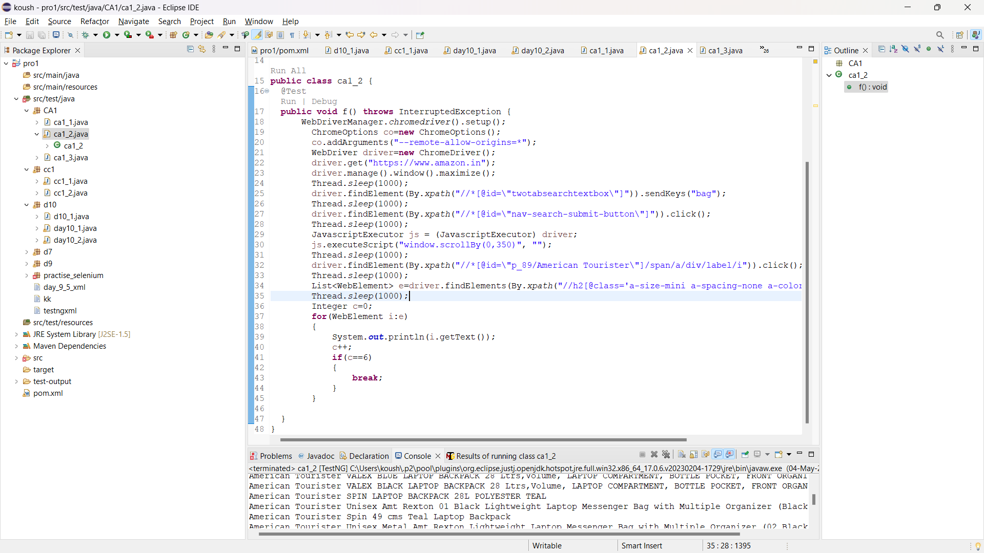

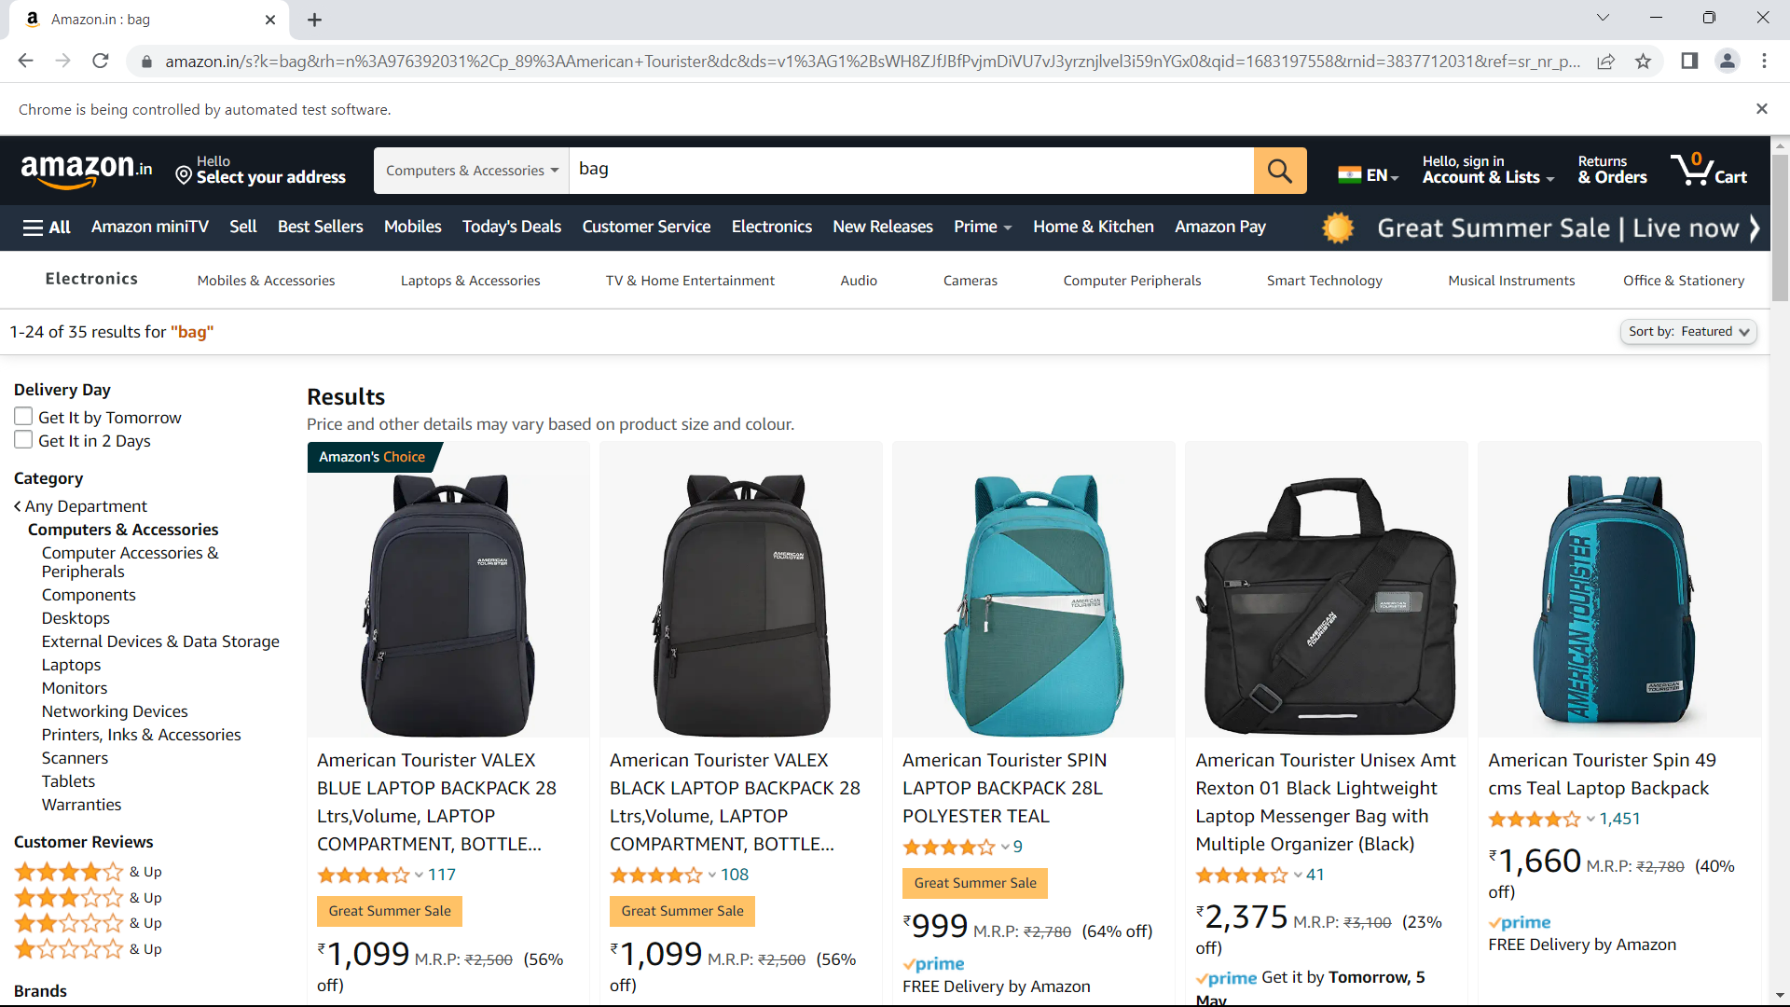

QNO:2

**package** CA1;

**import** org.openqa.selenium.By;

**import** org.openqa.selenium.WebDriver;

**import** org.openqa.selenium.chrome.ChromeDriver;

**import** org.openqa.selenium.chrome.ChromeOptions;

**import** io.github.bonigarcia.wdm.WebDriverManager;

**public** **class** ca1_1 {

**public** **static** **void** main( String[] args ) **throws** InterruptedException

{

ChromeOptions co = **new** ChromeOptions();

co.addArguments("--remote-allow-origins=*");

WebDriverManager.*chromedriver*().setup();

WebDriver driver = **new** ChromeDriver(co);

driver.manage().window().maximize();

driver.navigate().to("https://www.amazon.in/");

driver.get("https://www.amazon.in/Apple-Watch-GPS-Cellular-40mm/dp/B09G9717T5/ref=sr_1_1_sspa?crid=4YB7BW0NPGLA&keywords=apple%2Bwatch&qid=1683192816&sprefix=apple%2Caps%2C850&sr=8-1-spons&sp_csd=d2lkZ2V0TmFtZT1zcF9hdGY&th=1");

driver.manage().window().maximize();

String title = driver.getTitle();

String etitle = "Apple Watch SE (GPS + Cellular, 40mm) - Space Grey Aluminium Case with Midnight Sport Band - Regular";

System.***out***.println(title);

**if**(title.equals(etitle)) {

System.***out***.println("Title is matching");

}

**else** {

System.***out***.println("Title Mismatch");

}

driver.findElement(By.*xpath*("//*[@id=\"add-to-cart-button\"]")).click();

Thread.*sleep*(5000);

Boolean present = driver.findElement(By.*xpath*("//*[@id=\"attach-close_sideSheet-link\"]")).isDisplayed();

System.***out***.println("Is item added to cart:" + present);

driver.get("https://www.amazon.in/gp/cart/view.html/ref=dp_atch_dss_cart?");

Thread.*sleep*(5000);

driver.findElement(By.*xpath*("//*[@value=\"Delete\"]")).click();

Thread.*sleep*(2000);

String removeText = driver.findElement(By.*xpath*("//*[@id=\"sc-active-cart\"]/div/div[1]/div/h1")).getText();

String extext = "Your Amazon Cart is empty.";

**if**(removeText.equals(extext)) {

System.***out***.println("Product is removed");

}

driver.get("https://www.amazon.in/Apple-Watch-GPS-Cellular-40mm/dp/B09G9717T5/ref=sr_1_1_sspa?crid=4YB7BW0NPGLA&keywords=apple%2Bwatch&qid=1683192816&sprefix=apple%2Caps%2C850&sr=8-1-spons&sp_csd=d2lkZ2V0TmFtZT1zcF9hdGY&th=1");

driver.findElement(By.*xpath*("//*[@id=\"add-to-cart-button\"]")).click();

Thread.*sleep*(2000);

driver.get("https://www.amazon.in/gp/cart/view.html/ref=dp_atch_dss_cart?");

Thread.*sleep*(5000);

driver.findElement(By.*xpath*("//*[@id=\"a-autoid-0-announce\"]")).click();

driver.findElement(By.*xpath*("//*[@id=\"quantity_2\"]")).click();

Thread.*sleep*(2000);

driver.findElement(By.*xpath*("//*[@name=\"proceedToRetailCheckout\"] "));

Thread.*sleep*(1000);

String sign = driver.getTitle();

System.***out***.println(sign);

String esign = "Amazon Sign In";

**if**(sign.equals(esign)) {

System.***out***.println("Success");

}

**else** {

System.***out***.println("Failure");

}

}

}

OUTPUT:

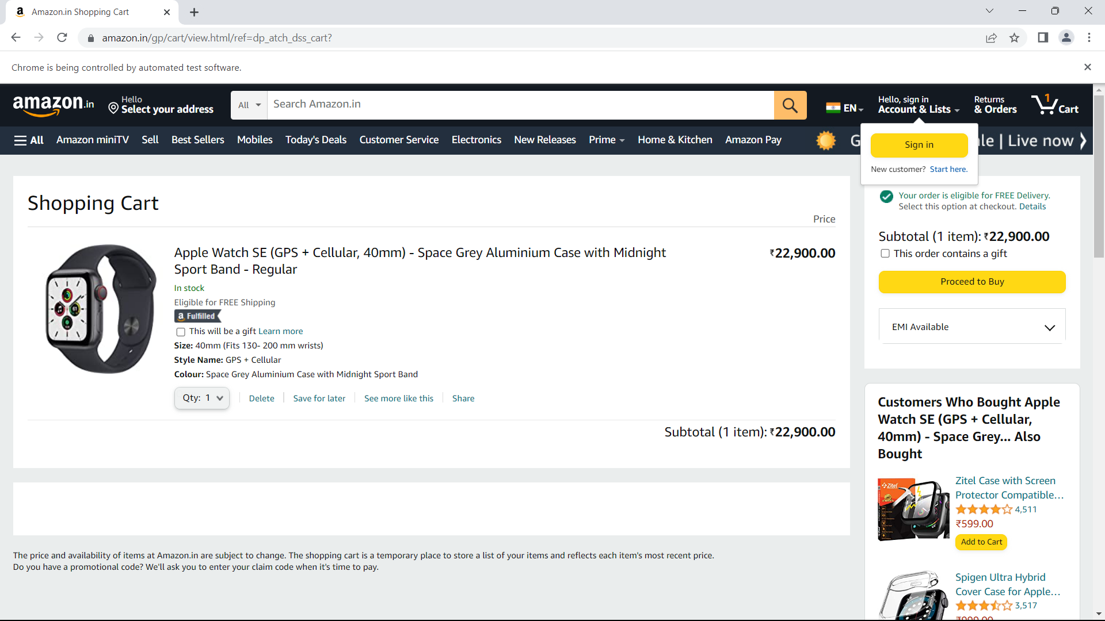

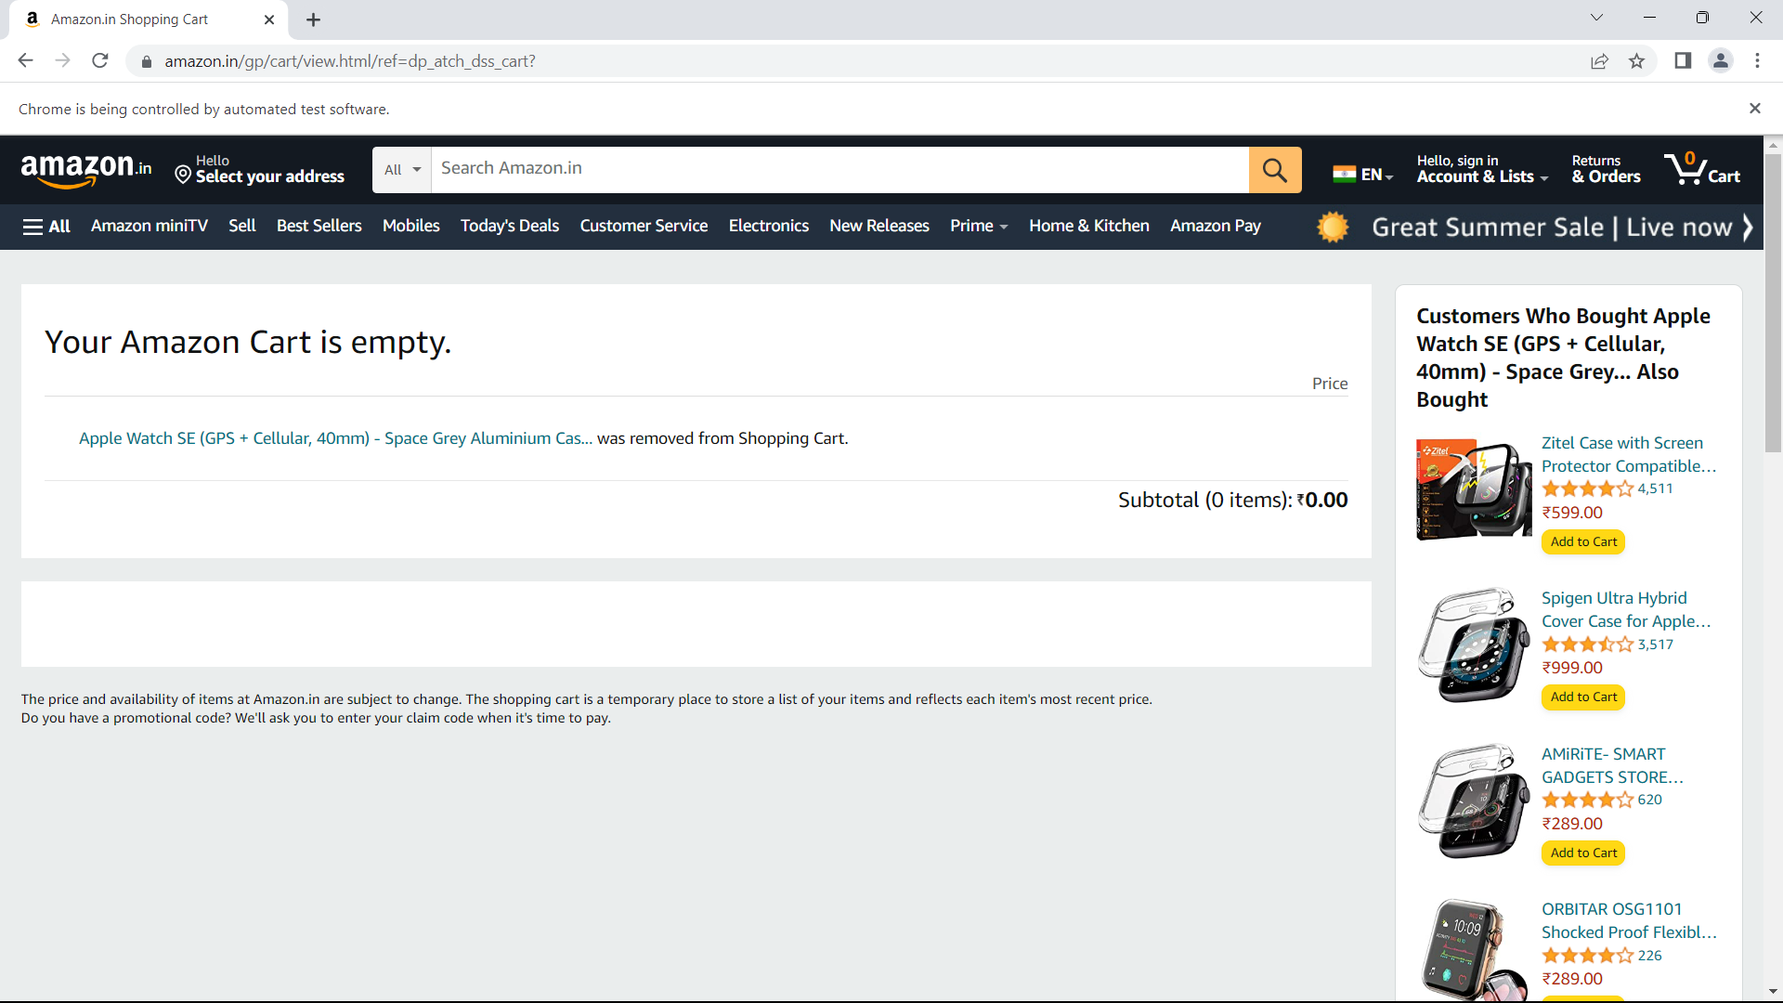

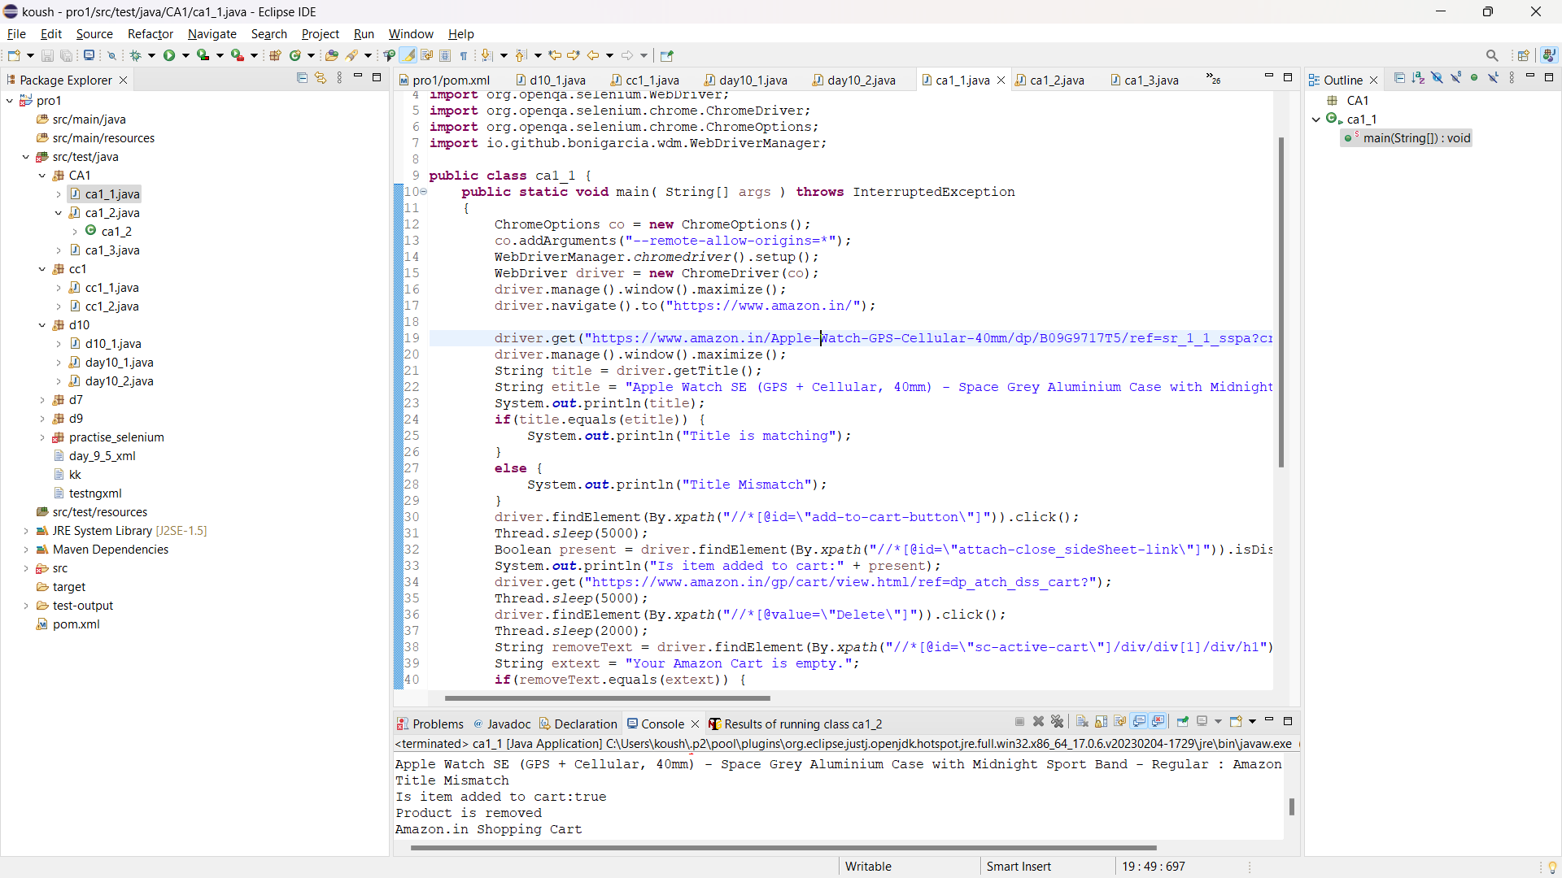

QNO:3

**package** CA1;

**import** org.openqa.selenium.By;

**import** org.openqa.selenium.WebDriver;

**import** org.openqa.selenium.chrome.ChromeDriver;

**import** org.openqa.selenium.chrome.ChromeOptions;

**import** org.testng.annotations.Test;

**import** io.github.bonigarcia.wdm.WebDriverManager;

**public** **class** ca1_3 {

@Test

**public** **void** f() **throws** InterruptedException {

WebDriverManager.*chromedriver*().setup();

ChromeOptions co=**new** ChromeOptions();

co.addArguments("--remote-allow-origins=*");

WebDriver driver=**new** ChromeDriver();

driver.get("https://www.amazon.in");

driver.manage().window().maximize();

Thread.*sleep*(1000);

driver.findElement(By.*xpath*("//*[@id=\"nav-link-accountList\"]")).click();

Thread.*sleep*(1000);;

driver.findElement(By.*xpath*("//*[@id=\"ap_email\"]")).sendKeys("7339217119");

Thread.*sleep*(1000);

driver.findElement(By.*xpath*("//*[@id=\"continue\"]")).click();

Thread.*sleep*(1000);

driver.findElement(By.*xpath*("//*[@id=\"ap_password\"]")).sendKeys("Cmkoushik5@");

Thread.*sleep*(4000);

driver.findElement(By.*xpath*("//*[@id=\"signInSubmit\"]")).click();

Thread.*sleep*(2500);

driver.findElement(By.*xpath*("//*[@id=\"nav-link-accountList\"]")).click();

Thread.*sleep*(500);

driver.findElement(By.*xpath*("//*[@id=\"a-page\"]/div[2]/div/div[2]/div[1]/a/div/div")).click();

}

}

OUTPUT:

